**Osaka Municipal Central Library**

英語 2019.4.

**Guidelines for Usage/Information**

OSAKA

MUNICIPAL

LIBRARY

■**Open hours** ●Monday-Friday (Every 1st and 3rd Thursday closed) 9:15～20:30

●Saturday/Sunday/Holiday 9:15～17:00

■**Closed** ●Every 1st and 3rd Thursday (Open if the day falls on a holiday)　　●Year-end and New Year Holidays　　●Inventory Check Period

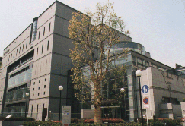**Welcome to the Osaka Municipal Central Library!**

Our facility is one of the largest municipality run libraries in Japan. We have over 2 million books in storage. In the reading rooms, from the basement level to the third floor, there are around 500,000 books, 3000 magazines, and 200 newspapers. There is a foreign language materials area on the 1st floor, with books, magazines, and newspapers in English, Chinese, Korean, Portuguese, Spanish, Thai, Indonesian, Vietnamese, Hindi, Tagalog, Malay, German and French.

**Making a Card** ■When making a library card for the first time, please fill out the “Application Form: User registration, Osaka Municipal Library”. For those over junior high school age, please bring something that shows your name and address (Driver’s License, Health Insurance Certificate, Student ID card, Student Handbook, Foreigner Registration Card, Residence Card, or Permanent Resident Card).

**Borrowing Materials** ■You may borrow up to a total of 15 items (Including up to 5 DVDs, videos, CDs, and cassettes) for 15 days.

**Returning Materials**　 ■Please return items by the due date.

■If the library is closed, please return items using the book drop. (Please do not put easily broken items like CDs and DVDs into the box.)

■If there is no reservation for the item, you may extend the due date by visiting the counter at the library, by telephone, or on the Internet.

■If you are extending the due date by phone, please have your Library Card’s number ready.

**Reservation Services** ■If the materials you are searching for are currently being checked out or are not on the shelves, please use the Reservation Service. You may reserve up to 15 items (including up to 5 DVDs, videos, CDs, and cassettes).

**Photocopying Services** ■Library materials may be photocopied for personal use only. (Under the Japanese Copyright Law).   
Before making copies, please tell the staff at the counter.

You may also view the Library Use guidance on the Library’s website.

(The page is available in English, Chinese, and Korean)

https://www.oml.city.osaka.lg.jp

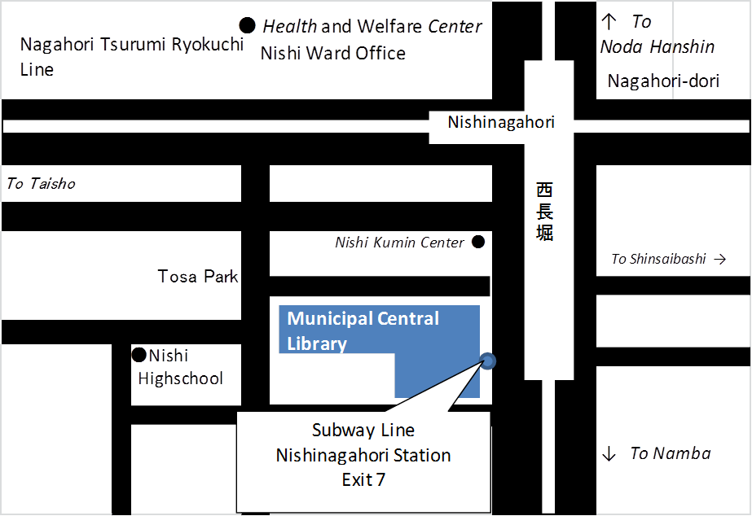Osaka Municipal Central Library

4-3-2, Kitahorie, Nishi-ku, Osaka, 550-0014

TEL 06-6539-3300（Information）

Borrowing/Returns ℡06-6539-3301　Searching/Consultations/Reservations ℡06-6539-3302

About books that were reserved　℡06-6539-3303

Services for the Disabled ℡06-6539-3304 　Mobile Library　℡06-6539-3305

For those hard of hearing or speaking,

please use the Fax Service (06-6539-3335).

※ Phone calls are in Japanese only.

Subway Sennichimae Line, Nagahori Tsurumi-Ryokuchi Line Nishi-Nagahori Station, Exit 7.

* **Internet and Mobile Phone Services**

　　　　　　　　Osaka Municipal Library website

　　　　　　　　　　PC version (English/Chinese/Korean available) https://www.oml.city.osaka.lg.jp

　　　　　　　　　　Mobile version (English available) https://web.oml.city.osaka.lg.jp/webopac/mobtopmnu.do

■There are many services available on our website, including inventory search, due date extensions, reservations, digital books, and services that don’t require you to visit the library.

Password ■For these services, you need your Library Card and a password (8 characters or more).

　　■For first time users, please visit your local library to have a password issued.

* **The library protects your borrowing history and private information**

■Your borrowing history is deleted after you return the materials. Your private information will not be used outside of the library.

■You may confirm your private details by asking the staff.

■Your private information is governed by Act on the Protection of Personal Information and by Osaka City’s Ordinance on the Protection of Personal Information.

* **Caution**

**Late Returns** ■Please return items borrowed by the due date. If you think you will not be able to return what you have borrowed on time, please contact the library. If there are no reservations on the material, you may extend the borrowing period only once, for 14 days.

■If you have materials that are over 15 days late, you will not be able to borrow new materials. If you are over 2 months late* you will not be allowed to use any service that requires a library card temporarily. If there is a special reason you will be late in returning an item, please inform the library ahead of time.

　　　　　　　　　　 ※　More than 2 months late will be subject to a 1 month suspension and over 1 year late, will be subject to a 6 month suspension of borrowing privileges.

**Lost or Damaged Books** ■Please take care not to lose, spill water on, or dirty the materials. In particular, please be careful of sudden rains that may wet the materials. Never write on or cut out the materials. Also, do not lend the materials to another person.

■If the borrowed materials are lost, broken, or damaged with water, you will be required to pay for a new item, according to the rules. If the material is broken, or damaged with water, please bring it to the library.

　　　　　　　　　　　　　　　　　　　　※The rules for replacing an item are as follows

　　　　　　　　　　　・For books, magazines, and CDs, if it is possible to obtain the same item, you will be required to purchase it.

　　　　　　　　　　　　　　　　　　　　　　　・For items that are no longer obtainable, you will be required to pay for a replacement item of the same price, such as the latest issue of a magazine.

　　 ・For videos and DVDs, we are unable to accept any items without copyright consent, thus, the library will require you to purchase a substitute item through our designated system.

**Lost Library Cards** ■If you lose your Library Card, please contact the library immediately. The card will be canceled, to prevent fraudulent use.

■Next, please visit the library with an item that can confirm your name and address (the same item you used when creating the card). A temporary library card will be issued.

■After issuing the temporary library card, if your Library Card cannot be found after one month’s time, you will be able to have your card reissued.